**MANAV RACHNA INTERNATIONAL**

**INSTITUTE OF REASEARCH & STUDIES**

**FACULTY OF ENGINEERING AND TECHNOLOGY**



**PRACTICAL FILE**

**FOR**

**VIIth SEMESTER (ACADEMIC YEAR 2021-2022)**

**SUBJECT NAME: ITNS Lab**

**SUBJECT CODE: BCS-DS-774**

|  |  |
| --- | --- |
| **SUBMITTED BY:-** | **SUBMITTED TO:-** |
| **STUDENT NAME: Neha Batra** | **FACULTY NAME: Dr. Savita** |
| **ROLL NO.: 1/19/FET/BCS/022** | **DEPARTMENT: FET** |
|  |  |
|  |

**INDEX**

|  |  |  |  |
| --- | --- | --- | --- |
| **PRACTICAL NO.** | **AIM OF PRACTICAL** | **DATE ON WHICH CONDUCTED** | **TEACHER’S SIGNATURE** |
|  | To Install Kali Linux | 27/07/22 |  |
|  | To Install Windows 7 | 27/07/22 |  |
|  | To Implement all commands on NMAP for Network Scanning | 17/08/22 |  |
|  | To Implement ARP Spoofing | 3/08/22 |  |
|  | To Implement Nessus basic Scan | 31/08/22 |  |
|  | To Perform DNS Spoofing Attack | 10/09/22 |  |
|  | To use Metasploit framework to exploit system | 14/09/22 |  |
|  | Implementation of Foot Printing Lab | 21/09/22 |  |
|  | Implementation of Cryptography Labs | 28/09/22 |  |
|  | Implementation of File System Security | 5/10/22 |  |
|  | Implementation of Network Security Tools and Technologies Lab | 26/10/22 |  |

**EXPERIMENT -01**

**AIM**- **Installation of virtual box and windows 7**

VirtualBox is a cross-platform virtualization application. What does that mean? For one thing, it installs on your existing Intel or AMD-based computers, whether they are running Windows, Mac, Linux or Solaris operating systems. Secondly, it extends the capabilities of your existing computer so that it can run multiple operating systems (inside multiple virtual machines) at the same time. So, for example, you can run Windows and Linux on your Mac, run Windows Server 2008 on your Linux server, run Linux on your Windows PC, and so on, all alongside your existing applications. You can install and run as many virtual machines as you like -- the only practical limits are disk space and memory.

VirtualBox is deceptively simple yet also very powerful. It can run everywhere from small embedded systems or desktop class machines all the way up to datacentre deployments and even Cloud environments.

The following screenshot shows you how VirtualBox, installed on a Mac computer, is running Windows 8 in a virtual machine window:

**STEPS FOR INSTALLATION OF VIRTUAL BOX: -**

**PART-1: CREATE THE VIRTUAL MACHINE**

**STEP-1: Download VirtualBox.** VirtualBox from Oracle is available for free from the developer's website. Make sure that you download the correct version for your operating system.

* There are multiple choices for Linux or Windows versions. Choose the package that matches your Linux or Windows distribution or use the "All distributions" option if your Linux distribution is not listed.

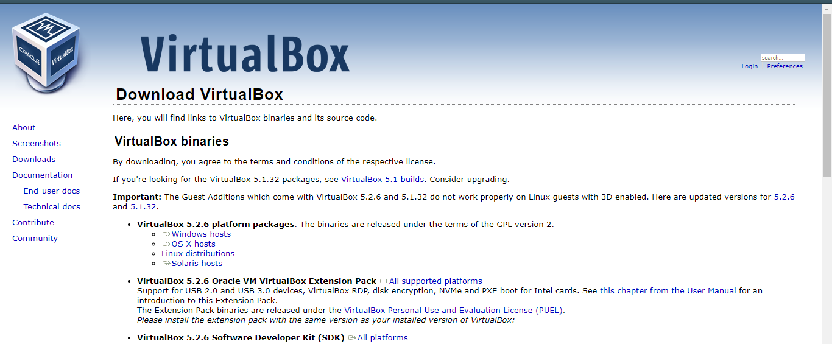

**STEP-2: Install the VirtualBox program.** If you are using Windows, double-click the setup file and follow the prompts to install. If you are using a Mac, open the DMG file that you downloaded and drag the VirtualBox file to your Applications folder.

* During the Windows installation, keep all the options set to their default.

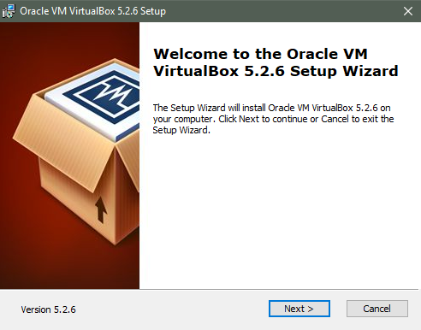

**STEP-3: Start the program.** VirtualBox allows you to manage your various virtual machines, and easily create new ones. You can run VirtualBox directly from the installation program, or you can start it from the desktop icon.

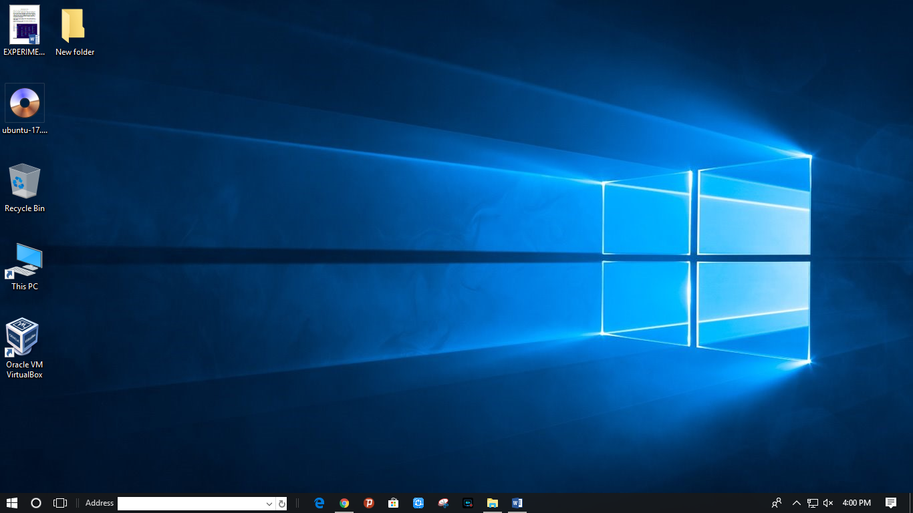

**STEP-4: Gather your installation disc(s).** When creating a virtual machine, you will need to install the operating system just like you would on a regular computer. This means that you will need the installation discs for the operating system you want to install on the virtual machine.

* If you download the ISO file for the installation disc, you can burn it to a blank DVD, or install it directly from the ISO file.

**PART-2: Windows installation in Virtual Box**

* **To Install Windows 7 inside of VMware Workstation**
* Download and install VM ware
* Insert the Windows 7 install DVD into your drive
* Run VMware Workstation 7.0 from the Start menu
* Click **New Virtual Machine**  
   [[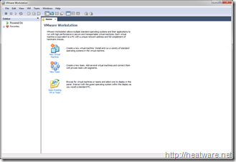](http://heatware.net/wp-content/uploads/2009/11/vmware_windows_7_14.png)](http://heatware.net/wp-content/uploads/2009/11/vmware_windows_7_14.png)
* Choose **Typical** and click **Next**

[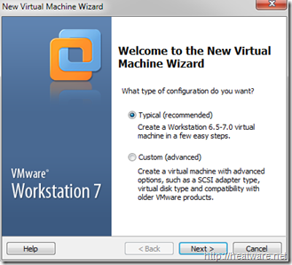](http://heatware.net/wp-content/uploads/2009/11/vmware_windows_7_2.png)

* Choose the option **Installer Disc** and ensure that the optical drive that has the Windows 7 installation DVD is selected.  
  Note: If you have Windows 7 as an ISO image, choose the option labelled: Installed disc image file (iso)

[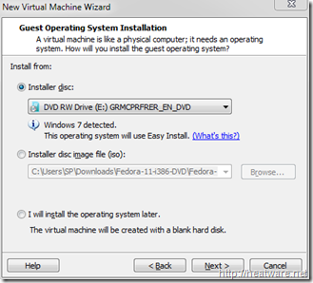](http://heatware.net/wp-content/uploads/2009/11/vmware_windows_7_3.png)

* A convenient new feature is the ability to specify your Windows 7 product key prior to starting the installation to allow for a fully-unattended install. No more coming back to your computer an hour later after you think the installation finished only to find it stuck on a screen asking for a serial number!  
  Go ahead and enter your **Windows product key**and **Full name**. The password is optional. Click **Next**.

[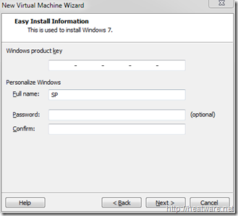](http://heatware.net/wp-content/uploads/2009/11/vmware_windows_7_4.png)

* Now it is time to name the virtual machine and choose the location. We will keep the default location and name the VM **Windows 7 Pro**

[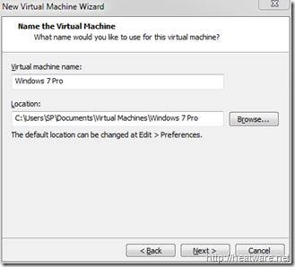](http://heatware.net/wp-content/uploads/2009/11/vmware_windows_7_5.png)

* VMware needs to know how hard drive space to allocate to the Windows 7 disk. Lets stick with the 40.0 GB default and click **Next**.

[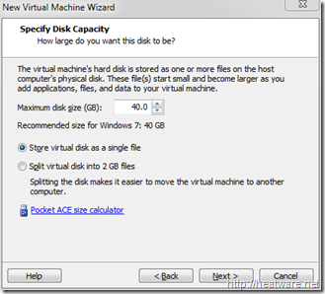](http://heatware.net/wp-content/uploads/2009/11/vmware_windows_7_6.png)

Now you will be presented with a summary screen that shows all the VM configuration parameters. Don’t worry, you can change most of these at any time! Click **Finish** to begin the installation!

[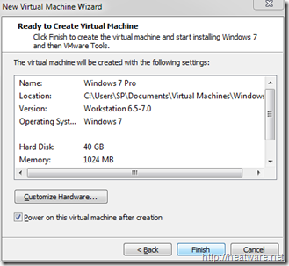](http://heatware.net/wp-content/uploads/2009/11/vmware_windows_7_7.png)

* The virtual machine will now boot up and load the Windows 7 installer from the DVD. If you need to step away from the computer, go ahead, no more user-intervention is needed.

[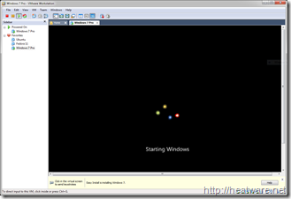](http://heatware.net/wp-content/uploads/2009/11/vmware_windows_7_8.png)

* The installer will now copy files… This will take a while…

[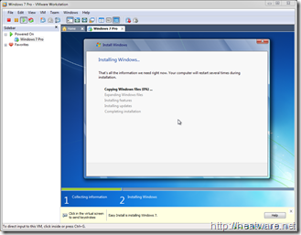](http://heatware.net/wp-content/uploads/2009/11/vmware_windows_7_9.png)

* Your system will reboot…

[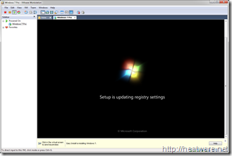](http://heatware.net/wp-content/uploads/2009/11/vmware_windows_7_10.png)

* And continue installing…

[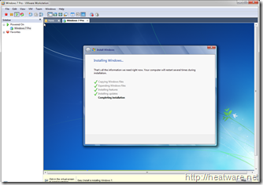](http://heatware.net/wp-content/uploads/2009/11/vmware_windows_7_11.png)

* And about 30 minutes later, its all done!

[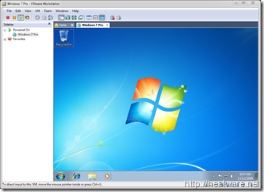](http://heatware.net/wp-content/uploads/2009/11/vmware_windows_7_12.png)

* Now is a great time to save the state of your VM by taking a snapshot. This way, if you shut down VMware, you don’t have to start all over again! Right click on *Windows 7 Pro* in the left panel and choose **Take Snapshot**

[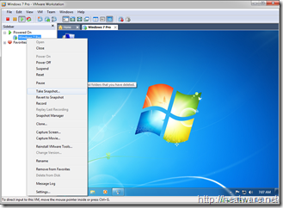](http://heatware.net/wp-content/uploads/2009/11/vmware_windows_7_13.png)